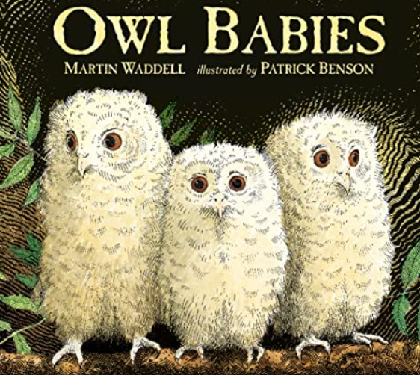
The weather since September has been amazing and the children have enjoyed all of their time spent outdoors. They love the bubbles, parachute and nature sessions. They have quickly adapted to school life and are familiar with the routines. It has been especially a joy to us, observing how well the children play together and show kindness and friendship. They have enjoyed celebrating being kind when taking Bob home on a play date. Having only 23 in our class, we have had a chance to spend lots of quality time with the children in small groups, chatting and playing. We are looking forward to the learning ahead this half term.
Communication and Language
Through play, the children listen to each other and take turns in conversation. In our circle times, we always look at how important it is to look and listen when our friends are talking. When speaking and through phonics, the children are working on speaking clearly and expanding their vocabulary. The children will again use Talk for Writing to learn a new story. This time it will be ‘Owl Babies’. This links with our science and maths learning about night and day and nocturnal animals. We will have a real owl visit from Fen’s Falconry.
Vocabulary: digraph, phoneme, blend, segment, owl, nocturnal, day, night, tallons,
Literacy
This our half term our focus book will be The Owl Babies. The children will learn this story using actions and the story map. Lots of activities will be based around this story with making characters using natural objects and clay as well as using junk modelling to make owls. When we have a visit from a real owl, the children will be encouraged to listen carefully and ask questions about the owls, how they behave and what they eat for example. We will continue with our Read Write Inc sessions for phonics based reading. In our writing areas, the children will have word mats with vocabulary linked Owl Babies. The children will draw and write captions to match parts of the story. As we approach Christmas, the children will write letters to Santa and invitations to come and watch our Nativity play.
Vocabulary: caption, invitation, word, sounds, nativity, story map, story, owl.
Physical Development
PE is definitely a favourite activity in our class as we have been using the apparatus in the hall. We will continue to do this and will focus on jumping and landing safely as well as encouraging the children to think about moving in different ways. In these sessions, we always talk about our body and which muscles we can feel working hard. The children are continuing to practise dressing and undressing independently. At playtimes, we will continue to use the trikes and for the children to carry passengers. On windy days we use the ribbons and materials for kites and Jabadao equipment such as the big elastic band where the children can all fit into and move around as a team.
Vocabulary: move, direction, travel, strength, muscles, veins, blood, heart, diet, exercise, healthy, unhealthy.
Personal, Social and Emotional Development
This half term our Happy Mind theme is ‘Celebrate’. These lessons will help children understand their unique character strengths and build positive self-esteem.
- Character Strengths: Children learn to identify and celebrate their own personal strengths as well as recognise them in others.
- Science-Backed Model: Looking at strengths, teaching that character traits are shaped by both genetics and experience through neuroplasticity.
- Self-Esteem & Confidence: Children feel great about who they are, supporting resilience and mental well-being.
Through everything we do, the children are learning to manage their feelings and behaviour, to have a good attitude to learning and to build resilience. We have established our class rules that all of the children contributed to. The children are already beginning to know that their views count and we often vote on choices such as which book they would like to read or whether to have a snack before or after play. In our regular circle- times we will discuss our likes, dislikes, for the children to know that their opinions are important. We will talk about how to be a good friend, or to recognise and deal with a range of feelings. ‘Bob’ our class mascot will continue to go home with children for a play date who have shown kindness during the week.
The children love our peer massage sessions, we will build on this with mindfulness sessions on how to stay calm, ways to improve self-belief and a can-do attitude, how to deal with negative feelings or how to improve focus and listening skills. In November, we will use ‘Anti- bullying week’ to focus on the importance of making everyone feel accepted and welcome and that certain behaviours are not acceptable.
Vocabulary: similar, different, tolerant, vote, attitude, resilience, independent, bully, accept, negative, positive, unique, family, relationships, interests.
Mathematics
It’s me 1,2,3. The children will be working with numbers 1,2 and 3 to count, order and show different ways of representing the numbers with dots, actions or objects. Looking at composition, the children will be challenged to think of different ways to make 4. 3+1, 4+0 2+2 inside and outside the classroom and in lots of different ways. There will be lots of number hunts outside. The children will be encouraged to devise their own games involving timers and counting or matching amounts to numbers on a dice. They will use clipboards to record their scores. The children will focus on positional language by playing hide the owl, they need to hide it for a friend and then give directions of how to find it. With shapes they will focus on circles and triangles and go on shape hunts to find them around the school. In the art area, they will look at art work by Kandinsky and then use 3d shapes to print.
Light and Dark: The children will match number names to numerals. With the small world toys such as the farm animals, they can sort them into animals with 2 legs or 4 legs. More number hunts and number games outside. They will look at addition and subtraction with one more or 1 less than amounts up to 5. For shapes, we will move on to shapes that have 4 sides. Going on a square and rectangle hunt around school. We will look at combining shapes to make other shapes. We will introduce the children to vocabulary linked to time. Through stories but also by setting up obstacle courses allowing the children to describe how it works. Such as: first, then, after that, next.
Vocabulary: number, shape, subitise, compare, different, same, more, less, up, down, on, under, behind, next, after that, circle, triangle, square, sides, straight, curved.
Understanding the World (Science, Religion, History, Geography)
Our autumn walks create lots of learning and discussions, we will continue to observe the changing season and with a focus on decomposing fruits, plants and leaves. We will look at ‘hibernation’ and how people and animals deal with the change in weather as it gets colder. We will read We’re going on a bear hunt and go outside and investigate mud and water. Looking at changes in science, we will investigate cornflour water, ice and chocolate. For Bonfire night, the children will delve into the past and learn about King James and Guy Fawkes. We will link it to modern day by finding out about King Charles, London and the Houses of Parliament. On Remembrance day we will look at the importance of remembering and talk about our own lives and the lives of our family. The children will make a class poppy wreath. As we get closer to Christmas, the children will learn about the Nativity. We will talk about the Christian Faith and introduce the children to becoming aware of different faiths particularly within our school. Our Religion and World Views lessons will also look at how Christians celebrate Christmas and special times for other faiths such as Diwali for Hindus.
Vocabulary: decompose, rot, nutrient, hibernate, nocturnal, gather, royal, treason, parliament, democracy, remembrance, Nativity, king, Jesus, Mary, Joseph, stable, manger, Bethlehem.

Computing
We will take a simple look at computing systems and networks. This will involve looking at computer keyboards. The children will use this to find the letters in their name and to see how a mouse and a keyboard work.
Expressive Arts and Design
The most exciting event to look forward to this half term is our Nativity. We will start practising the songs and learning words for our performance straight away. There will be lots of drama and singing with our owl babies story and Santa’s Grotto. In our music lessons we will be looking at a variety of celebration music: Diwali, Hannukah, Kwazaa and traditional Christmas songs. In our art area, we will start with leaf printing and using the clay and objects outside to make woodland creatures. We will go on another leaf hunt to find leaves to make an autumn wreath. By doing dough disco each week, the children are comfortable with moulding the dough into different shapes. They will develop these skills to create their own woodland creatures. First with dough, then with the clay.
Vocabulary: nativity, clay, celebrate, celebration, print, draw, create, repeat, mould, perform, artist, audience, rehearsal, costume.
USEFUL WEBSITES
http://www.bbc.co.uk/education/topics/zf44jxs/videos/1
https://www.bbc.co.uk/cbeebies
https://www.oxfordowl.co.uk/
http://www.crickweb.co.uk/Early-Years.html
http://www.phonicsplay.co.uk/freeIndex.htm
http://www.ruthmiskin.com/en/parents/

Key dates
02/11/26 – Autumn term 2 begins
02/11/26 – Parent Consultation Evening 1
04/11/26 – Parent Consultation Evening 2
05/11/26 – Bonfire lunch
09/11/26 – Christmas Performance 09:15am
13/11/26 – Children in Need
10/12/26 – Christmas jumper day
16/12/26 – Christmas Lunch
17/12/26 – Christmas disco
18/12/26 – final day before Christmas
Important dates for early 2027:
04/01/27 – Staff training day: school closed
05/01/27 – Spring term begins
12/02/27 – Spring term 1 ends for half term

